**Ex. No.: 8**  Date: 31-03-2022

**Problem statement:**

Create an APP for capture image from the camera and store it in database by using Android studio.

1. Using Camera by Using Camera Application

2. Using Camera By using Camera API

3. Camera Permission Declarations in Manifest

4. Camera Example in Android Studio by Using Camera Intent and storing the camera

**Design: (Block diagram)**

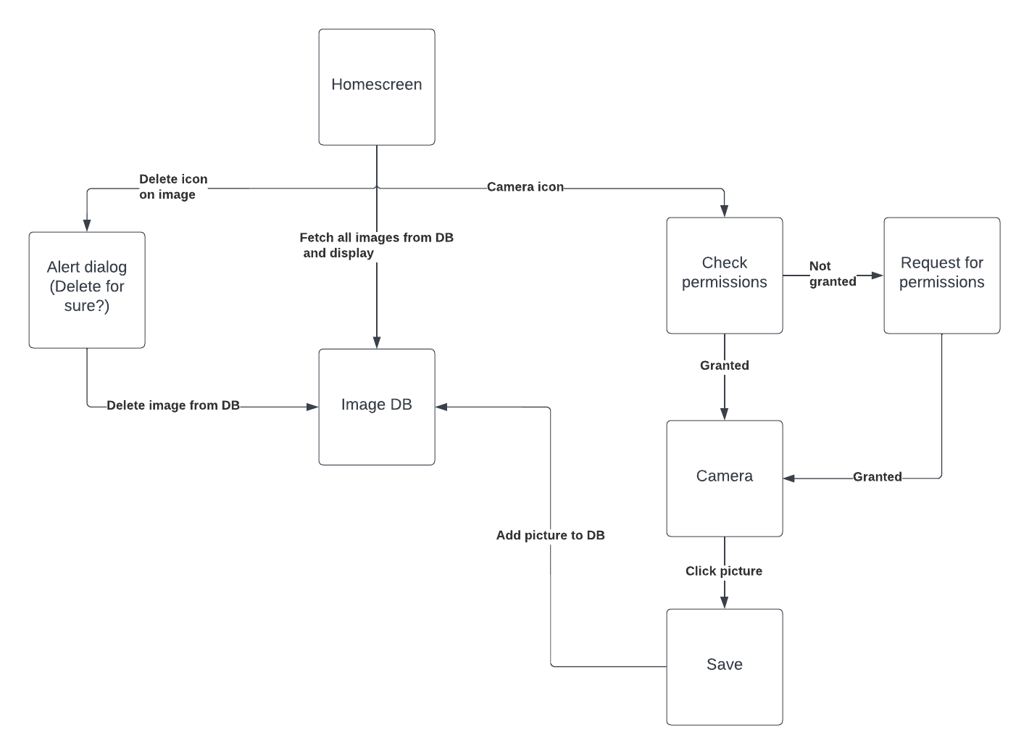

**Tool used:**

* Android Studio
* Java
* XML
* Camera API
* SQLite Database

**Code:** <https://drive.google.com/drive/folders/1yHlfokWtgY7mpmzB4WT5wDgRodWq2n-i?usp=sharing>

**Screenshots of application:**

